Social Media Training Seminar


GOAL: Train agents on how to more effectively use Facebook, LinkedIn, and Twitter to help build their businesses.
OBJECTIVES:
- Upon completing this training seminar, agents will be able to DEFINE Social Media with 80 % accuracy

- Upon completing this training seminar, agents will be able to RECOGNIZE why Social Media is relevant to real estate

- During this training seminar, agents will be able to DISCUSS new ways to use social media to market their business

- Upon completing this training seminar, agents will be able to IDENTIFY the most efficient forms of social media for real estate

- Upon completing this training seminar, agents will be able to APPLY new social media knowledge and skills to social media websites with 80% efficiency

- Upon completing this training seminar, agents will be able to DIFFERENTIATE what should and should not be done on social media pages

- During this training seminar, agents will be able to ESTABLISH effective Social Media Strategies for the agents

- Upon completing this training seminar, agents will be able to JUSTIFY using social media pages to build their business

Table of Contents

How to Create a Professional Facebook Page …………………… Page 3

How to Create a LinkedIn Account………………………………… Page 9

Tips for LinkedIn ……………………………… ………… .……… Page 11

How to Create a Twitter Account ……………………………..…… Page 15

How to Market Your Business Using Twitter …… .…………..… Page 18

Social Media Glossary……………………………………………… Page 22

How to create a professional Facebook Page

- Open your personal Facebook Page

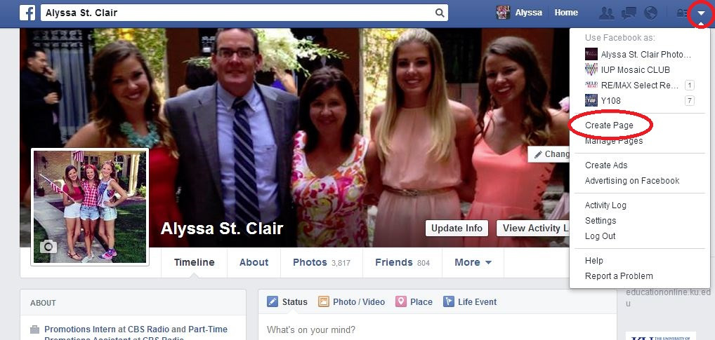
- Go to upper right hand corner, click arrow for the drop down menu. Click “Create Page”

- This page will appear. Click local business or place, the first option on your computer screen
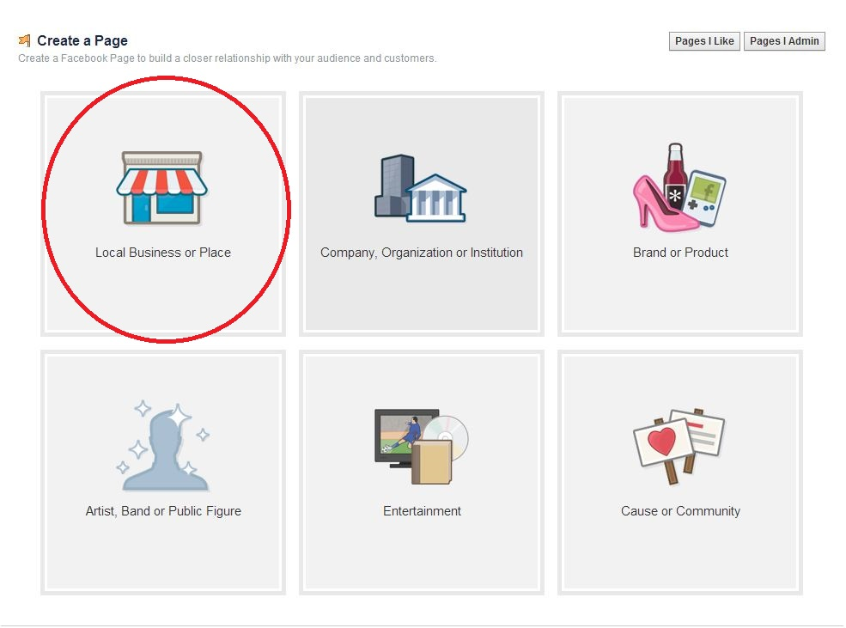

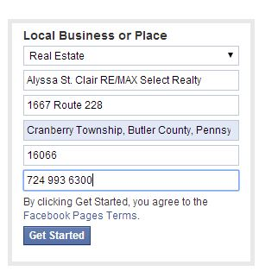
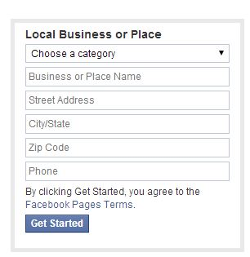
- This information box will appear on your page. Under Category, select Real Estate, and then fill out the information accordingly. By clicking the “Get Started” button, you are agreeing to Facebooks Terms & Uses

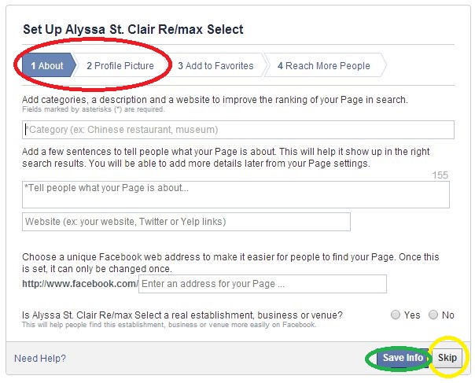
- After clicking “Get Started”, this page will appear, fill out the new information box. You have the option to “Skip” this step, but I advise that you fill out at least tabs 1 (“About”) & 2 (Profile Picture) to get started. Once your finished filling in you info, be sure to click Save Info

  - Note: The sections with astricts (*) are required to be filled out

  - You can select multiple CATEGORIES – this will allow you to come up in more search results – see image below

  - Adding a few sentences (155 characters) to “Tell people what your page is about” will inform your audience what your page is about and allow you to come up in the correct searches – see image below

  - Adding a link to your WEBSITE will drive more traffic to it directly from your Facebook
    - *SUGGESTIONS- Add selecthomefinder.com , your twitter account, any personal websites you have, LinkedIn, etc.* -see image below

  - Choosing a unique web address will help people find your page more easily. *NOTE: THIS CAN ONLY BE CHANGED ONCE<, SO CHOOSE WISELY!!! Suggestion: Use your full name, followed by RE/MAX Select Realty –see image below

  - Click YES for both options at the bottom of the first info page – see image below

  - Be sure to click SAVE INFO when finished – see image below

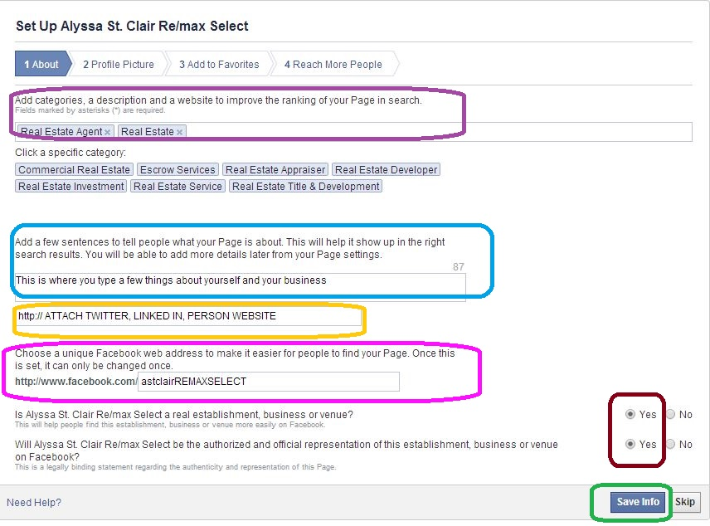

- TAB 2 Profile Picture: You will have the option to upload an image from your computer, or important an image from a website. Do whatever you feel comfortable
    - *SUGGESTIONS- use a Professional Headshot with a RE/MAX Select Realty Logo to help brand your page
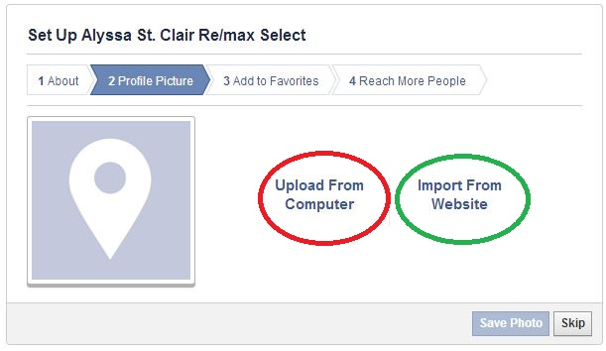

- Here is where you can add favorites to your page & pay to boost your posts. These are both really great tools for building your page, but you can go back and do this at anytime. We just want to focus on setting up your page, so for the purposes of this training, SKIP the next two steps
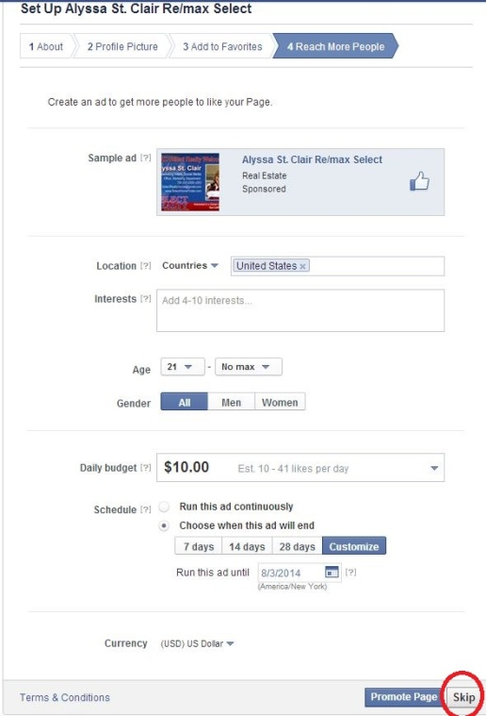
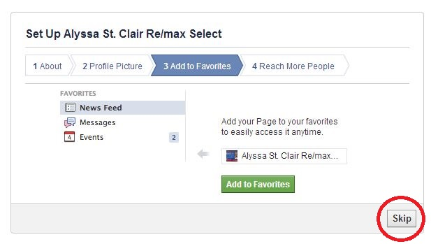

- HERE IS YOUR PAGE- after skipping the previous steps, it will bring you to your page. This will be very similar to how you built your personal Facebook page. Follow the color coded steps to utilize your page
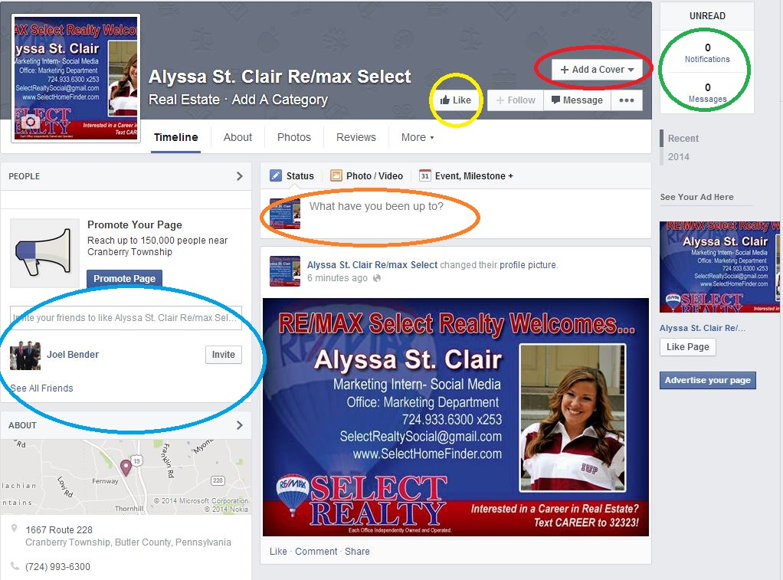

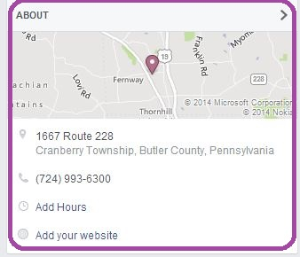

- One of the most important parts of your Facebook Page is your COVER PHOTO. This is how you can brand your facebook page. SUGGESTION: Be sure you use something that has RE/MAX Select Realty in it (logo, business card, sold sign, etc). You can upload a photo from your computer

- Get your NOTIFICATIONS on the right side- your notifications are people that are engaging with you through your page. You can also check these in the upper right hand corner

- LIKE your own page

- Invite all of your friends/family to like your new professional Facebook page

- Upload text and images to let people know what you have been up to. This is where you can post listings, open houses, images of happy customers, relevant tips, snippets etc.

- In the lower left hand side of your page, you will find your “ABOUT” section. Enter your office phone number, hours, websites, etc. here so that your audience will know when and where they can get a hold of you

- CONGRATULATIONS! You have created a professional Facebook Page! This is a great tool that you can use to help build an online presence!!! Get comfortable with sharing posts, images, and links to help build your page and your audience! THIS WILL TAKE PATIENCE AND PERSISTENCE, but if you keep up with it, it will be very effective!

If you need extra assistance, here is an excellent online tutorial that can help you out!
https://www.youtube.com/watch?v=Dp6JbsaFn9A

How to Create a LinkedIn

- In your web browser, go to www.linkedin.com

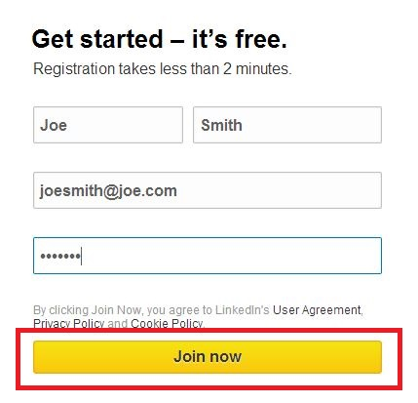
- This page will appear. Fill out the following information. Then click “Join Now”

- Next, this page will appear. Fill out the follow information. Then click “Create My Profile”
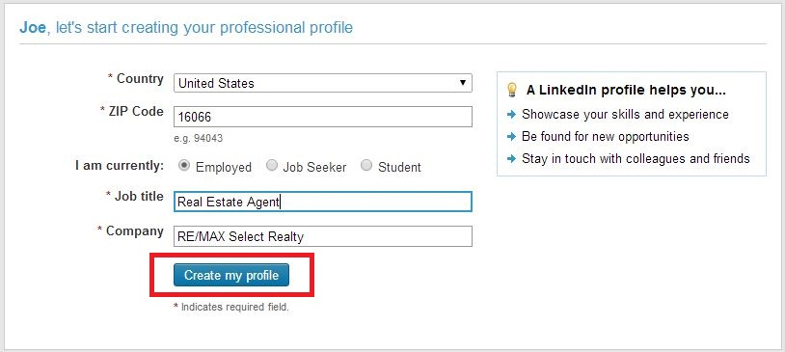

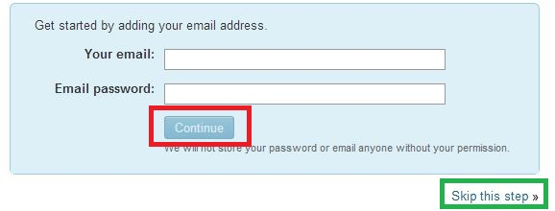
- Next, this page will appear. Fill out the following information then click “continue”. You also have the option to “skip” this step.

- A confirmation email will be send to your email with a link. Click the link to confirm the activation of your account.

- Congrats! Now you are now ready to build your account! This is what your page will look like. Use the tips on the following page to help build a profile that will stand out.
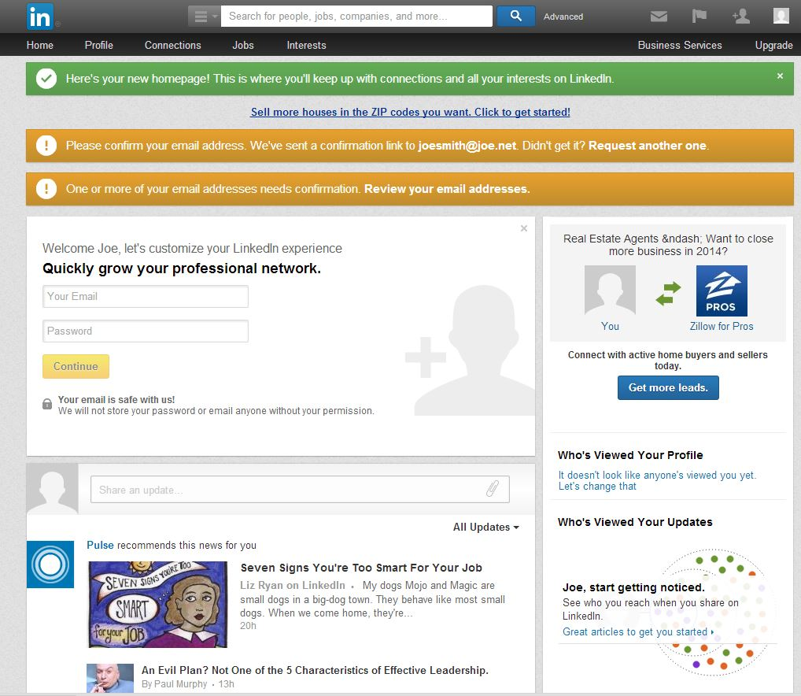

Tips for building a LinkedIn Profile

This visual aid shows you WHAT to add and WHERE to add it on your LinkedIn Profile
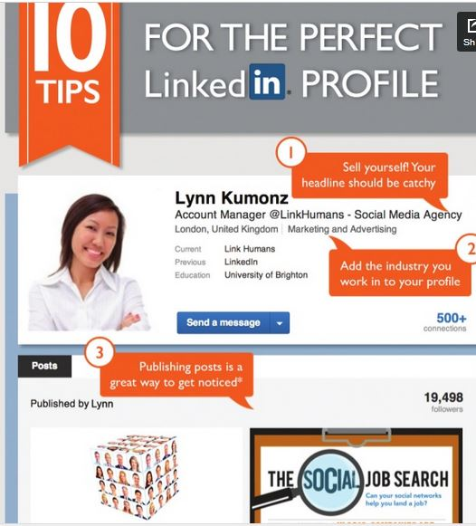

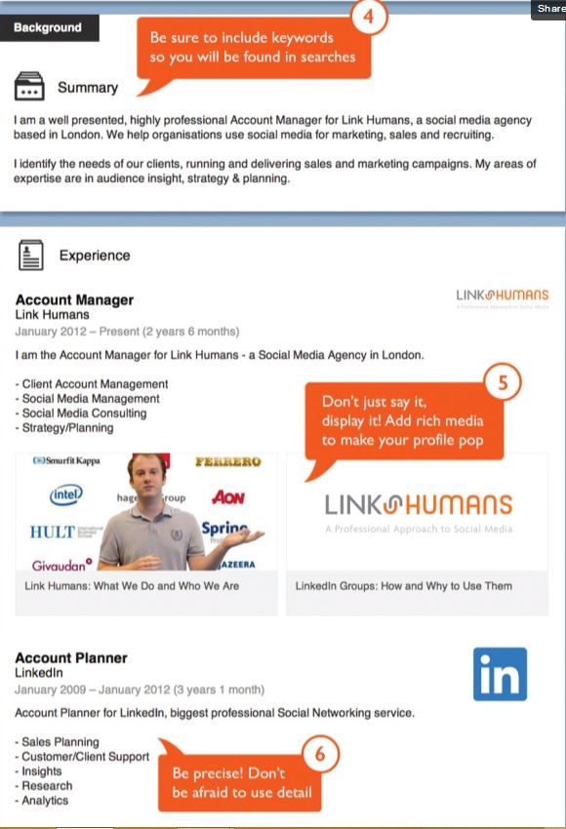

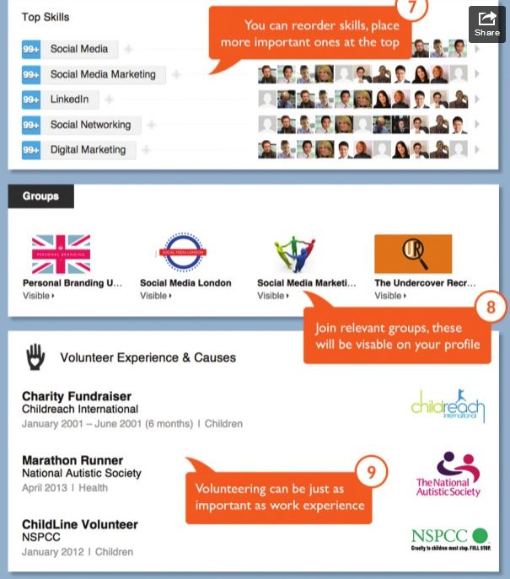

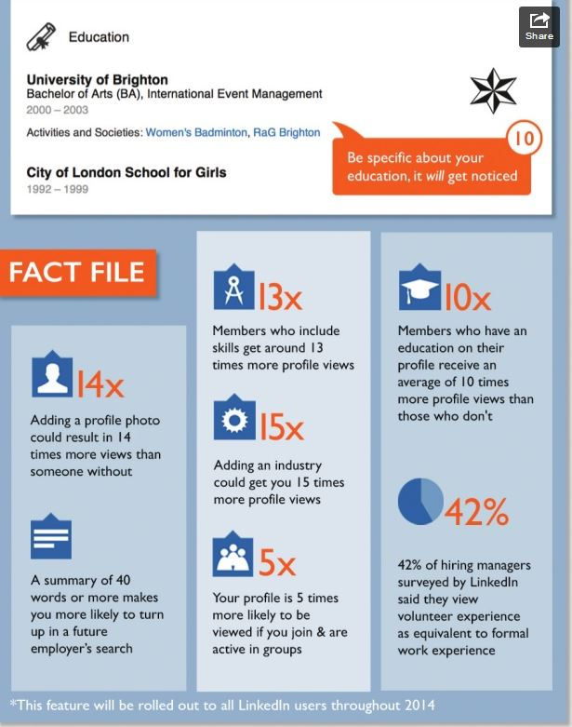

How to Create a Twitter Account

- In your web browser, go to www.twitter.com

- You will see this page on your web browser. Fill out the following information in the “New To Twitter?” box and then click “Sign Up For Twitter”

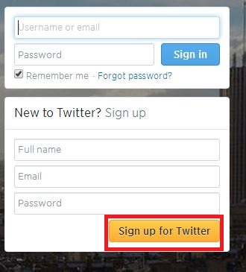

- Your web browser will then bring you to this page. Fill out the information prompted. This is where you will pick a username. *SUGGESTION* - pick a name that has REMAX, RSR, SelectRealty, etc. in it somewhere to help build your brand. Click “Create my account” when you are finished.
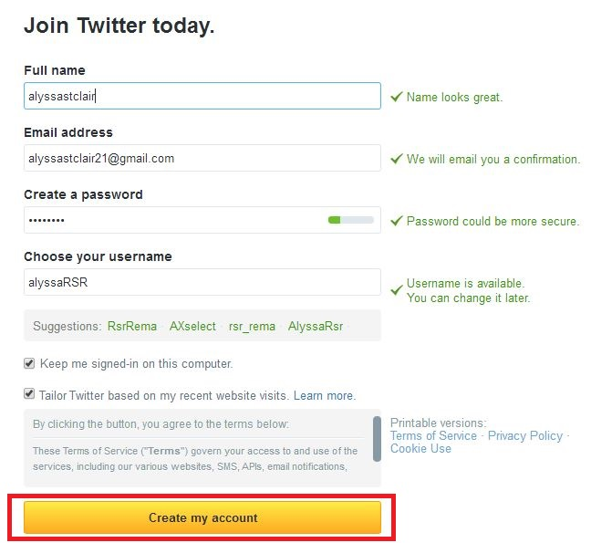
- Twitter will then prompt you with 3 simple steps to get you started. Follow these easy steps to get started. You will also have the option to skip these steps. Once you are finished, it will bring you to your home page

- This is your homepage. Begin to build your profile by selecting a PROFILE PICTURE and putting valuable info your BIO. Go to SETTINGS to do this (see step 6 for details). On the right of your screen, you will be able to search people to follow. You can also search people to follow by typing their name directly into the search box. You will be able to see your @mentions by click the NOTIFICATIONS icon at the top left of the page. You will also be able to view what your profile looks like to other users by clicking the “ME” icon at the top of the page. You can compose a tweet by clicking the TWEET in the upper right hand corner, or by directly typing into the “Compose new tweet” box on the left side of your screen. Check your Direct Messages by clicking the MESSAGE icon at the top right of you screen, right next to your TWEET Icon.
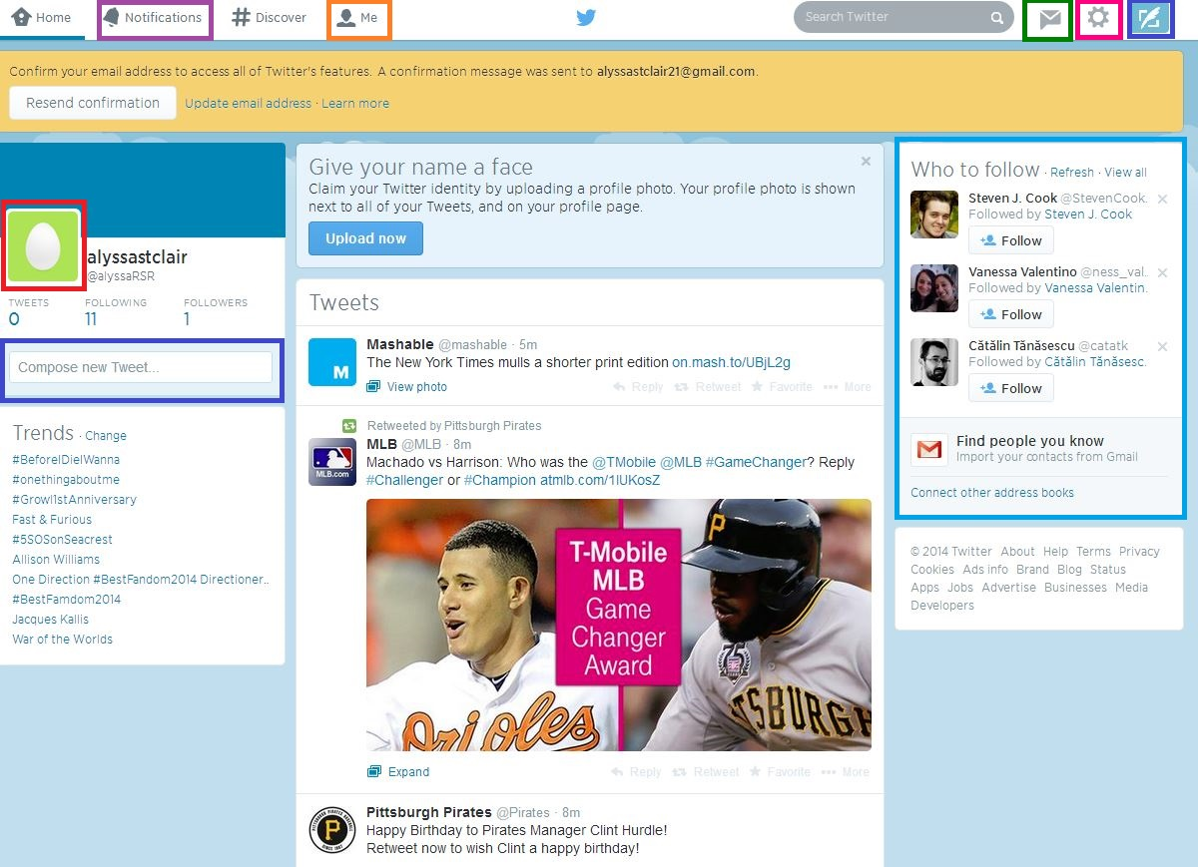

- Settings: If you ever want to change anything on your profile, go to your SETTINGS ICON (see image on step 5) and select the first tab “EDIT PROFILE”. It will then bring you to this page. This is where you can select a PROFILE PICTURE, change your HEADER PHOTO, enter your LOCATION, attach your WEBSITE, and enter info into your BIO. You also have the option to attach your Twitter account to your Professional Facebook Page. This will make things more simple for you and save you time. This allows all of your tweets to go onto directly your Facebook Page. You don’t have to do this, but it is something you may want to consider.
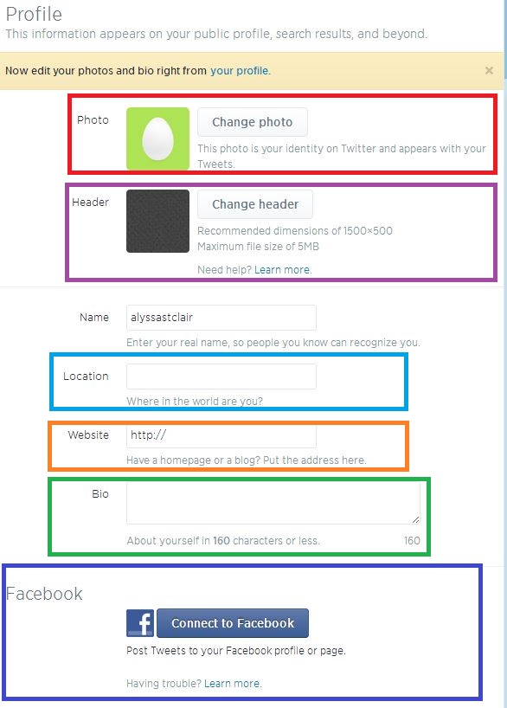

- Be sure to save all of your changes. Once this is complete, you are ready to go! Use the following visual aid to give you tips on how to use twitter to market your business!

How to Market Your Business Using Twitter


Step 1: Present your BRAND

This is the foundation of your twitter page. An important part of marketing is having your target audience be able to recognize your company. Your twitter page is a chance to help make your company more recognizable.

Your twitter page should have:
- The same look and feel as other online resources
- An account name that and profile image that is consistent with other online presences- EX.- @alyssa_REMAXSelect
- A customized background that people associate with your brand when they visit your twitter page

Example: Pepsi does a great job presenting their brand via twitter- Note: usage of logos, images, and relevant colors and username.

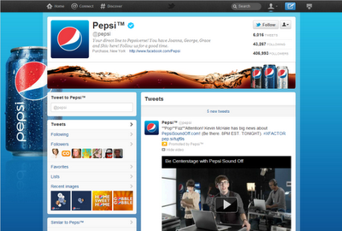

Step 2: Build a strong FOUNDATION

Complete your page by filling it with information under your account settings

Things that should be included:
- Location
- Company’s Website
- Company’s Facebook
- A Bio: 160 characters that SHOULD provide information about the benefits your company offers

Step 3: Start FOLLOWING people

Start to subscribe to other people, but be SELECTIVE. Only follow people who are relevant to your company.

People to follow:
- Your Customers
- Business partners
- Suppliers
- Contractors
- Vendors
- Competitors
- Peers
- Businesses nearby
- People in your professional network

Step 4: Start TALKING

After you complete building your profile, start talking, but TALK SMART. Find a sweet spot between what your target audience wants to hear and things that promote your business.

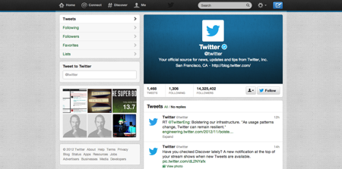

Compose a tweet by clicking where the blue arrows are pointing

What to say:
- Focus on how your products and services benefits your customers
- Answer questions
- Provide useful information to win over your new customers
- Experiment: see what gets the most responses

Step 5: Come up with a twitter COMMUNICATION PLAN

This is the what and when of how you strategically execute your tweets. Focus on topics that are designed to draw in potential customers, such as Q&A’s, contests, and more.

Plan WHAT to tweet, and WHEN to tweet it. Tweeting certain things at certain times may elicit more responses. Be strategic about what you are saying. Every company is different, so some of this will be based on trial and error.

Step 6: Drive TRAFFIC to your website

What to do:

- Tweet out your website link – EX. –selecthomefinder.com or your personal website
- Create a tweet around your link. Writing a message will compel people to click your link.
- Twitter will shorten your URL to 20 characters to save space to tweet more information

Step 7: Connect your ONLINE PRESENCE

Do this by:
- Putting links for all social media sites (Twitter, Facebook, LinkedIn) on your company’s website & visa versa
- Link your twitter timeline to your company’s website your tweets will appear on your official webpage along with providing easy access to your twitter account

Step 8: SHARE photos & videos

Plan & simple: People love photos and videos. Some people respond more to visual content rather than just words. Post photos and videos that are relevant to the benefits your customer will receive from using your products and services.

Social Media Glossary
FACEBOOK
FACEBOOK: an online social networking service that allows people to make and share posts/photos
PROFILE PICTURE: the main photo of you on your profile. Your profile picture appears as a thumbnail next to your comments and other activity on Facebook
COVER PHOTO: the large picture at the top of your profile, right above your profile picture.
LIKE: is a way to give positive feedback and connect with things you care about
SHARE: a way to share another person’s content by clicking the “Share” button underneath their post.

LinkedIn
LinkedIn: World’s Largest Professional Social Networking
CONNECTIONS: LinkedIn members who have accepted invitations to connect are connections. Connections can view profiles and networks of one another.
1ST-DEGREE CONNECTION: These are members with whom you have directly connected.
2ND-DEGREE CONNECTION: These are friends of a friend. These folks are designated by a 2nd-Degree icon on the profile, near the name and photo.
3RD-DEGREE CONNECTION: is a contact of one of your 2nd-Degree Connections
INBOX: works like an email inbox. It holds personal messages that are sent to you by other LinkedIn members.
INTRODUCTIONS: If you’d like to connect with someone you aren’t connected with, you can send that person an Introduction.
INVITATIONS: If you’d like to ask someone you know to join the LinkedIn network, you can send them an invitation.
NETWORK: Your network consists of your 1st-Degree, 2nd-Degree and 3rd-Degree connections.

TWITTER
TWITTER: Microblogging service that enables users to send and read short 140-character text messages, called "tweets".
TWEET: A message posted via Twitter containing 140 characters or fewer
RETWEET: The act of forwarding another user's Tweet to all of your followers
REPLY: A Tweet posted in reply to another user's message, usually posted by clicking the "reply" button next to their Tweet in your timeline. Always begins with @username.
HANDLE: A user's "Twitter handle" is the username they have selected
FOLLOWER: A twitter user that subscribes to your tweets
FOLLOWING: Subscribing to another accounts tweets. Their Tweets will now show up in your Timeline
@MENTIONS: The @ sign is used to call out usernames in Tweets, like this: Hello @REMAXSelectR! When a username is preceded by the @ sign, it becomes a link to a Twitter profile. (THIS IS HOW YOU INTERACT WITH PEOPLE ON TWITTER)
TIMELINE: Your homepage. All of the tweets of accounts you follow will show up here in realtime.
NOTIFICATIONS: The Notifications tab lets you view interactions, mentions, recent follows and Retweets. Using the Notifications tab you're able to view who has favorited or retweeted your Tweets, who has recently followed you, and all of your @replies and @mentions.
FAVORITE: To favorite a Tweet means to mark it as one of your favorites by clicking the yellow star next to the message.
HASHTAG: The # symbol, called a hashtag, is used to mark keywords or topics in a Tweet. It create a link on the keyword you are hashtagging, other users can click this to see what anyone is saying about that topic. Hashtagged words that become very popular are often Trending Topics. Note: CANNOT use special characters in the hashtag, ex- #RE/MAX. It must all be one word. If you are hashtagging more than one word, don’t add spaces. Example - #SelectHomeFinder
TRENDING TOPIC: A very commonly used hashtag (#KEYWORD)

